[](https://x.com/SR_Forum)[](https://www.youtube.com/channel/UC6DUyfCOiRJuhgZoI_GgNGw)[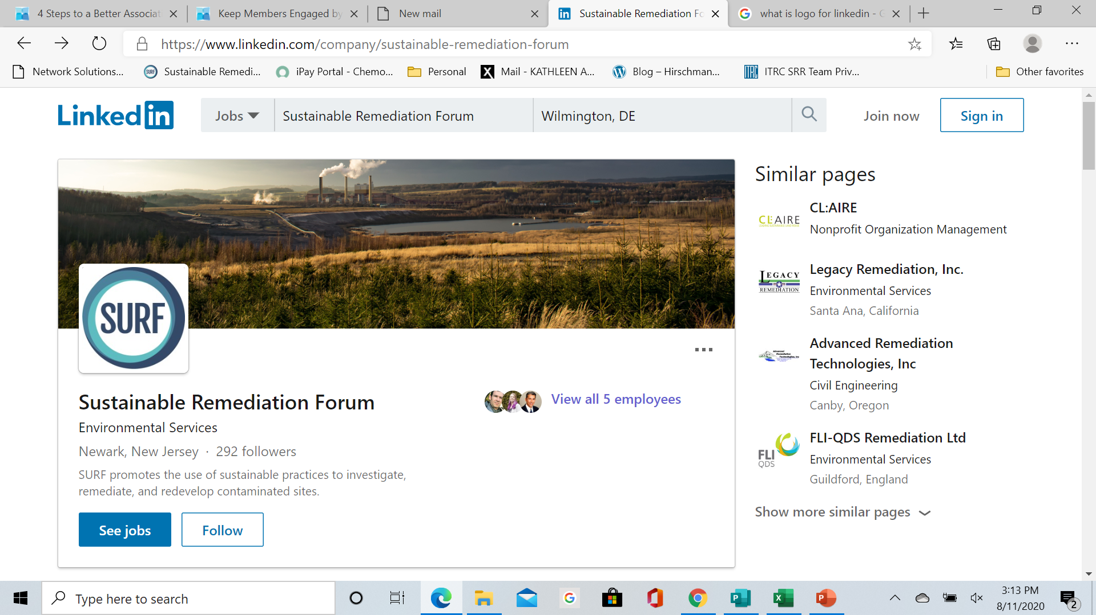](https://www.linkedin.com/company/sustainable-remediation-forum)**CASE STUDY TITLE HERE**

**[Date:](http://www.sustainableremediation.org)** Month, Year

[**www.sustainableremediation.org**](http://www.sustainableremediation.org)

**SURF Case Study #0000 [case study number will be provided by SURF]**

This case study highlights Lorem ipsum dolor sit amet, consectetuer adipiscing elit. Maecenas porttitor congue massa. Fusce posuere, magna sed pulvinar ultricies, purus lectus malesuada libero, sit amet commodo magna eros quis urna. Nunc viverra imperdiet enim. Fusce est. Vivamus a tellus.

* Lorem ipsum dolor sit amet, consectetuer adipiscing elit. Maecenas porttitor congue massa.

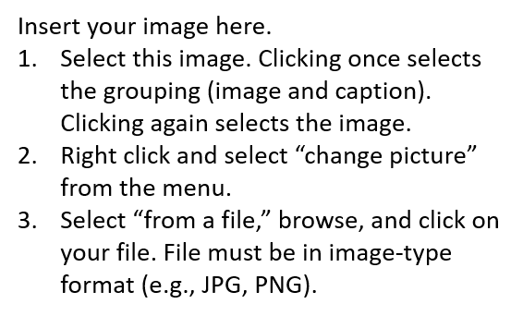

*Insert short caption here.*

**BACKGROUND**

* Fusce posuere, magna sed pulvinar ultricies, purus lectus malesuada libero, sit amet commodo magna eros quis urna. Nunc viverra imperdiet enim. Fusce est. Vivamus a tellus.
* Pellentesque habitant morbi tristique senectus et netus et malesuada fames ac turpis egestas. Proin pharetra nonummy pede. Mauris et orci.
* Lorem ipsum dolor sit amet, consectetuer adipiscing elit. Maecenas porttitor congue massa.

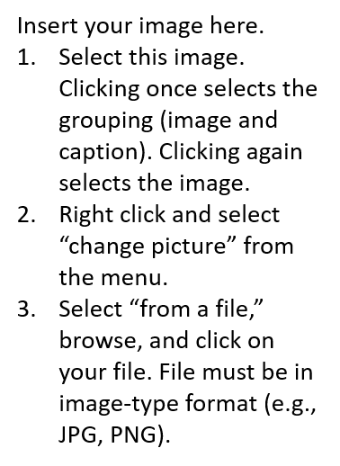

*Insert short  
caption here.*

*Regenerative blower with telemetry capabilities*

**REMEDIAL STRATEGY**

* Fusce posuere, magna sed pulvinar ultricies, purus lectus malesuada libero, sit amet commodo magna eros quis urna:
  + Suspendisse dui purus, scelerisque at, vulputate vitae
  + Nunc viverra imperdiet enim
* Pellentesque habitant morbi tristique senectus et netus et malesuada fames ac turpis egestas.
* Lorem ipsum dolor sit amet, consectetuer adipiscing elit. Maecenas porttitor congue massa. Fusce posuere, magna sed pulvinar ultricies, purus lectus malesuada libero.

**ENVIRONMENTAL FOOTPRINT ASSESSMENT**

* Pellentesque habitant morbi tristique senectus et netus et malesuada fames ac turpis egestas. Vivamus a tellus.

Placeholder for graph, etc.

Placeholder for graph, etc.

GWM, DPE, On-O2, Off-O2

GWM, On-O2, Off-O2, SVS

GWM, On-O2

GWM

GWM

GWM-Reduced

* Pellentesque habitant morbi tristique senectus et netus et malesuada fames ac turpis egestas. Vivamus a tellus.

**SOCIAL ASSESSMENT**

* Lorem ipsum dolor sit amet, consectetuer adipiscing elit. Maecenas porttitor congue massa. Fusce posuere, magna sed pulvinar ultricies, purus lectus malesuada libero.

Placeholder for graph, etc.

Placeholder for graph, etc.

**KEY LESSONS LEARNED**

**SUSTAINABLE REMEDIATION TRIPLE BOTTOM LINE**

* A picture containing computer

  Description automatically generatedFusce posuere, magna sed pulvinar ultricies, purus lectus malesuada libero, sit amet commodo magna eros quis urna. Nunc viverra imperdiet enim. Fusce est. Vivamus a tellus.
* Pellentesque habitant morbi tristique senectus et netus et malesuada fames ac turpis egestas. Proin pharetra nonummy pede. Mauris et orci.
* Purus lectus malesuada libero, sit amet commodo magna eros quis urna. Nunc viverra imperdiet enim. Fusce est. Vivamus a tellus.
* Et netus et malesuada fames ac turpis egestas viverra imperdiet enim.

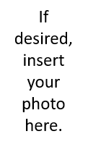

**This case study is the topic of a SURF webinar.**

**To access the webinar, click** [**here**](https://www.youtube.com/watch?v=t0H3A5ZRDZo)**.   
[If applicable, link will be provided by SURF.]**

**Case Study Contacts**

Name

Title

Organization

City, State (spelled out)

(XXX) XXX-XXXX

Email address (hyperlinked)

Organization website (hyperlinked)

Name

Title

Organization

City, State (spelled out)

(XXX) XXX-XXXX

Email address (hyperlinked)

Organization website (hyperlinked)

**FOR MORE INFORMATION…**